Homework 7 Report
Yalin Sun

Part II: The (Simulated!) Problem

Phase 1: Build Your Current System

1. Test Normal Operations:
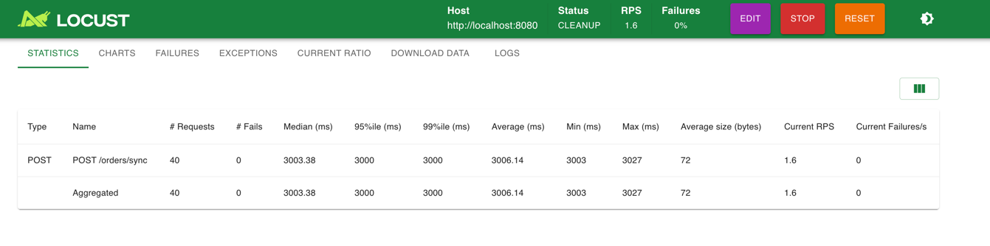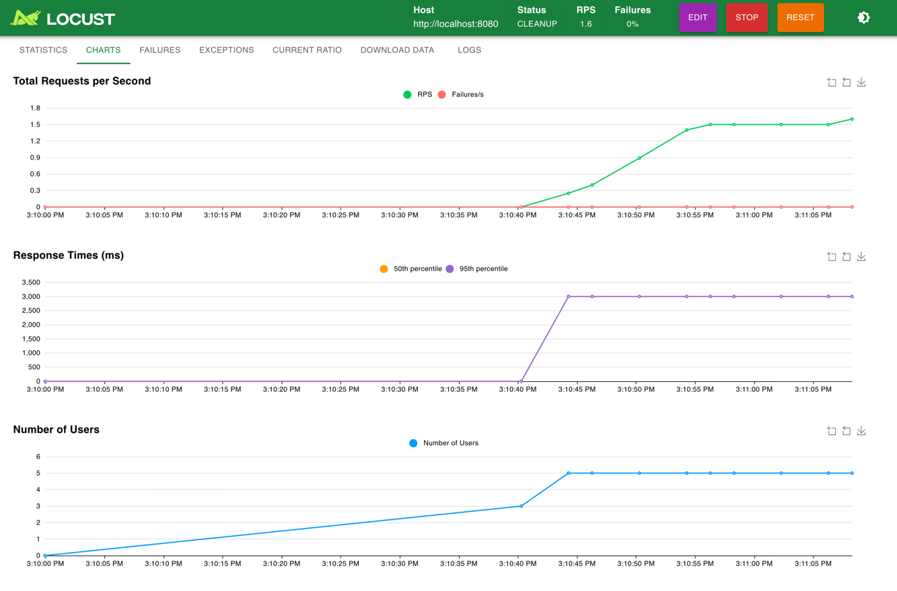

2. Test Flash Sale:

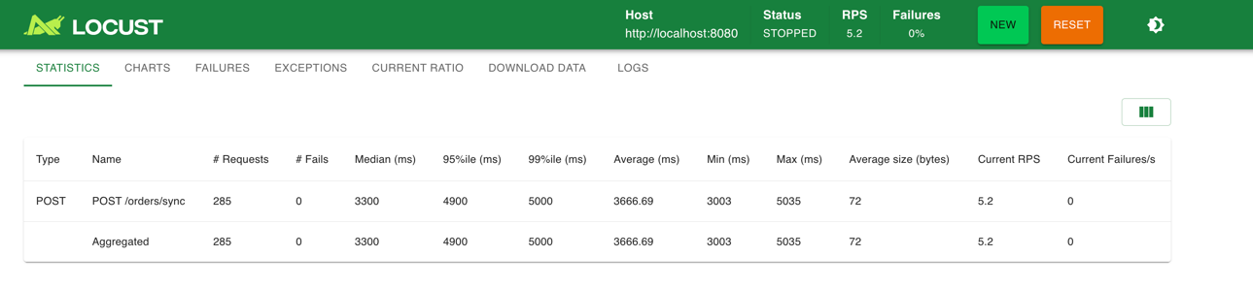

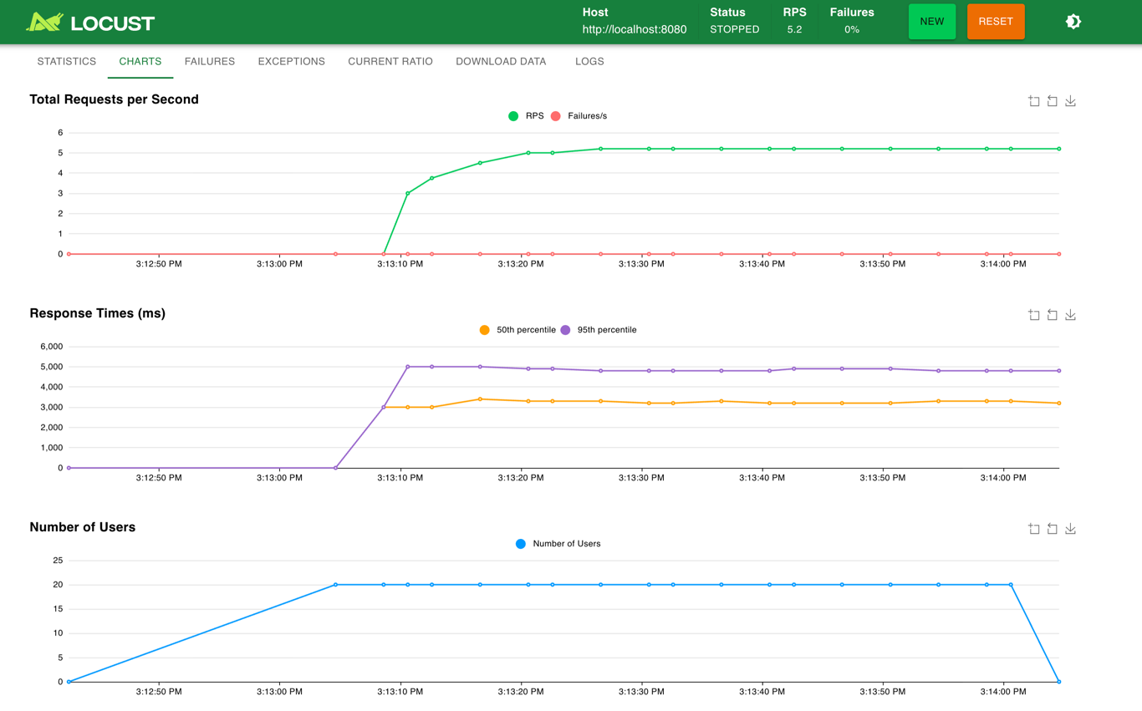
3. What happens to your customers.
Under normal load，customers still receive responses successfully, but each order already takes around 3 seconds because payment verification is synchronous.
During flash sale, the system throughput is capped by the payment processor at about 5 orders per second.
As demand increases, response time rises from about 3.0 seconds to around 3.7 seconds on average, with tail latency close to 5 seconds.
So the system does not fail immediately, but customers wait longer and experience degraded responsiveness.

Phase 2: Analyze the Bottleneck
(1) With 20 concurrent customers: Maximum throughput?
In my synchronous design, each payment verification takes 3 seconds. To simulate a realistic payment bottleneck, I used a buffered channel with capacity 15, which means at most 15 payment verifications can run at the same time. Therefore, the theoretical maximum throughput of the payment processor is:
15 / 3 = 5 orders per second.
(2) Orders lost per second
In the flash-sale scenario, the demand is 20 orders per second. Since the processor can only handle 5 orders per second, the gap is:
20 - 5 = 15 orders per second.
This means the system cannot keep up with incoming traffic under synchronous processing. Extra requests must wait for available payment slots, which increases response time and hurts customer experience.
(3) Compare to the Locust Results
The Locust results matched this analysis. Under normal load, the system processed about 1.6 requests per second with an average response time of about 3.0 seconds. Under flash-sale load, throughput rose to about 5.2 requests per second, which is close to the theoretical limit, but average response time increased to about 3.7 seconds and the 95th percentile reached about 4.9 seconds. This shows that the synchronous architecture becomes a bottleneck under higher load.
(4) What Can You Change?
Since the payment processor itself cannot be made faster, the main improvement is to change the architecture from synchronous processing to asynchronous processing. Instead of blocking the client until payment verification finishes, the system should accept the order immediately and process payment in the background.

Phase 3: The Async Solution
1. Test Flash Sale:

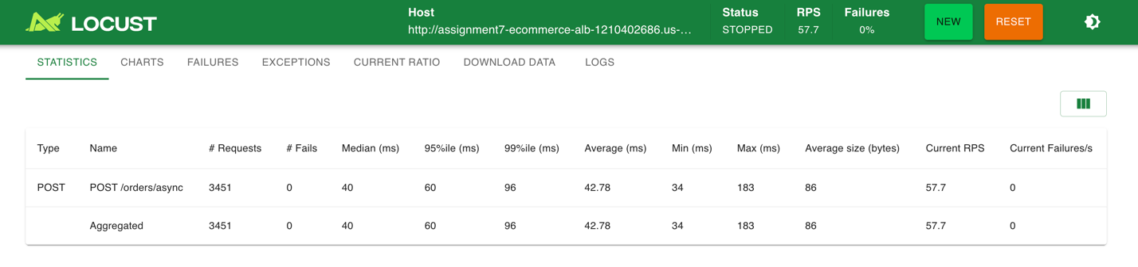

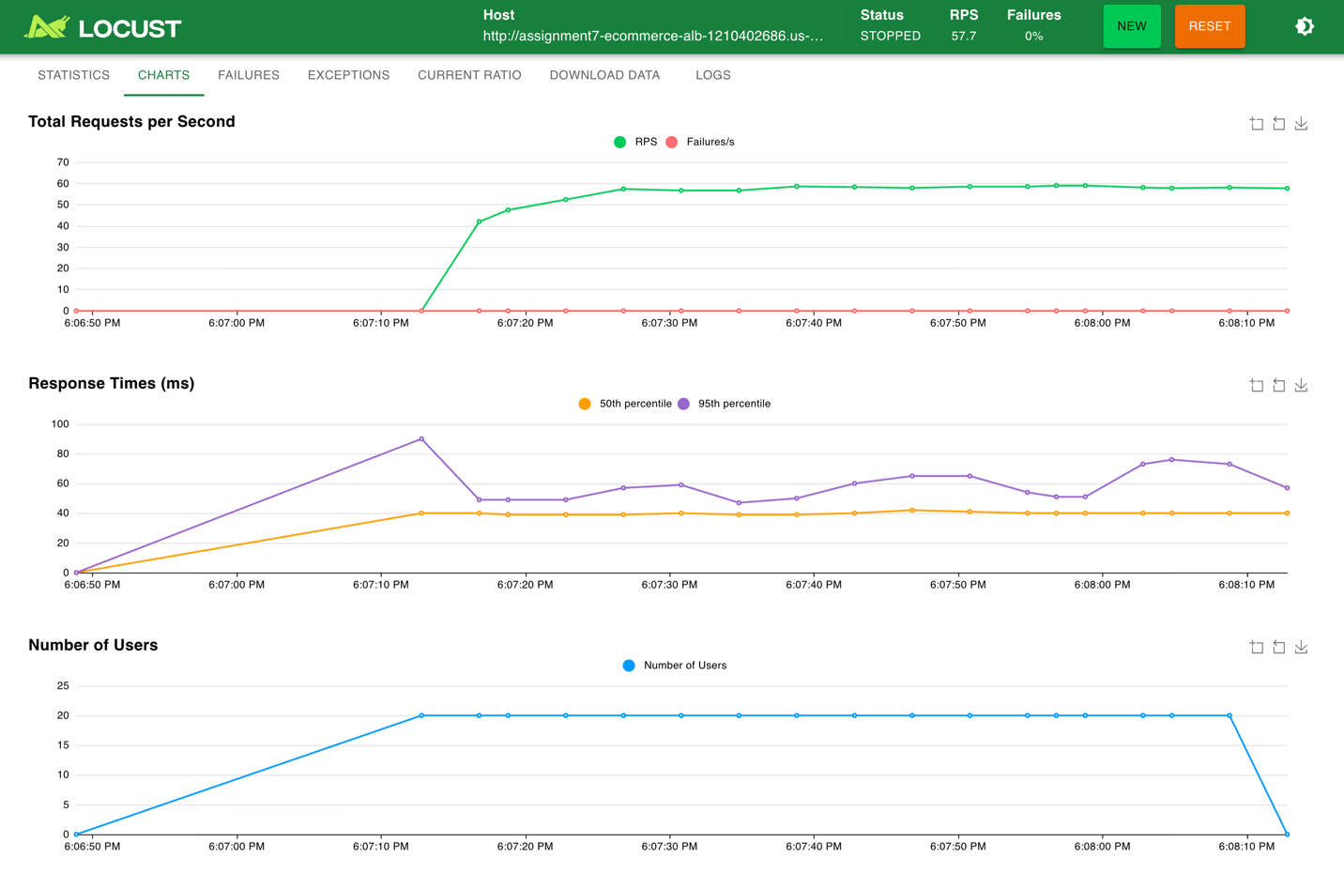

Same Flash Sale Test in Phase 3 achieved 100% acceptance rate: 3,451 requests, 0 failures, and about 57.7 requests per second. Response times were low (median 40 ms, 95th percentile 60 ms) because the API only enqueues the order and returns 202 Accepted; payment is processed later by workers.
The async design accepted about 12 times more orders in the same 60-second window (3,451 vs 285) and about 11 times higher RPS (57.7 vs 5.2). Both phases had 100% success rate, but only the async design could accept nearly all incoming demand without long waits. This shows that the event-driven flow (API → SNS → SQS → Order Processor) keeps the system responsive under flash sale load while still processing every order.

Phase 4: The Queue Problem

1. CloudWatch

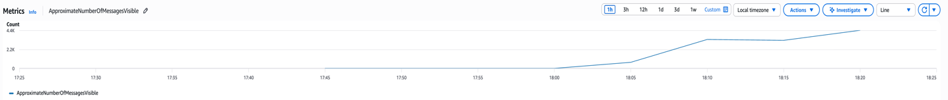

2. Analysis
Order acceptance rate: ~60/second
Single worker processing rate: 1 order per 3 seconds = 0.33/second
Queue growth rate: 60 − 0.33 ≈ 59.67
Time to clear backlog：
Cause the peak is 4000 in the metrics.
4000 ÷ 0.33 ≈ 12121 s ≈ 202 mins（about 3.4 hours）

3. Where’s my order confirmation?
Because orders are accepted immediately (202), but with only one worker processing at 0.33 orders per second, the queue builds up quickly and it can take hours to process the backlog, so customers do not get their confirmation for a long time.

Phase 5: Scale Your Workers

1. Screenshots

(1) 1 Goroutines

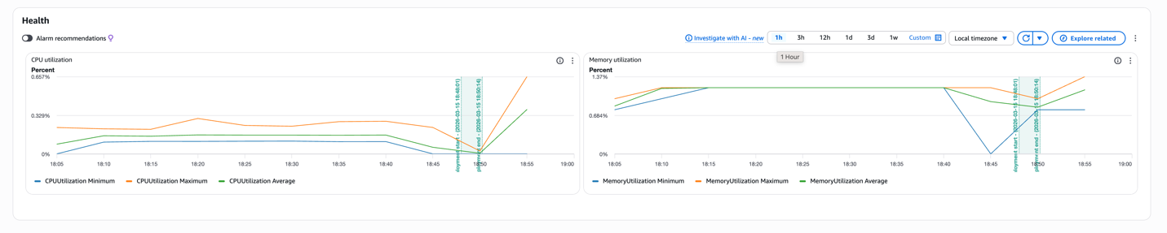

(2) 5 Goroutines

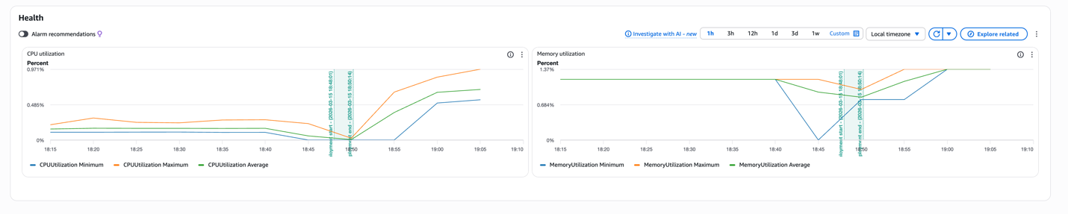

(3) 20 Goroutines

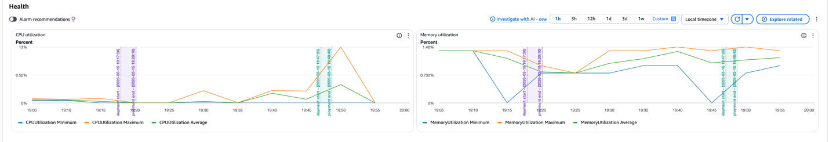

(4) 100 Goroutines



2. Comparison
Goroutines | Processing Rate | Peak Depth | Time to Zero | Resource Utilization
1 | 0.33 | ~4000 | ~3.4h | CUP~0.3%; Memory~1%
5 | 1.67 | ~3300 | ~33 mins | CUP~0.9%; Memory~1.3%
20 | 6.67 | ~2100 | ~5.3mins | CUP~2.87%; Memory~1.46%
100 | 33 | ~1000 | ~30s | CUP~13%; Memory~1.46%

Part III: What If You Didn't Need Queues?

1. Cold Starts

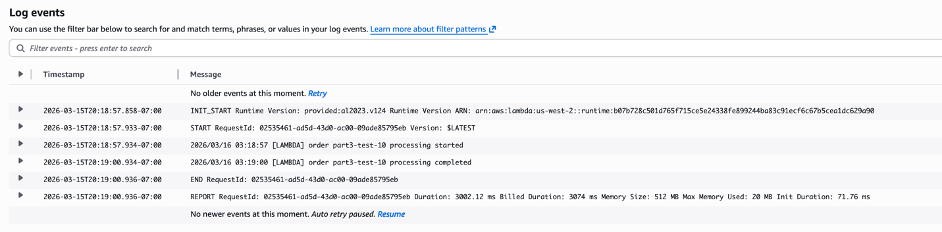

2. Warm Starts

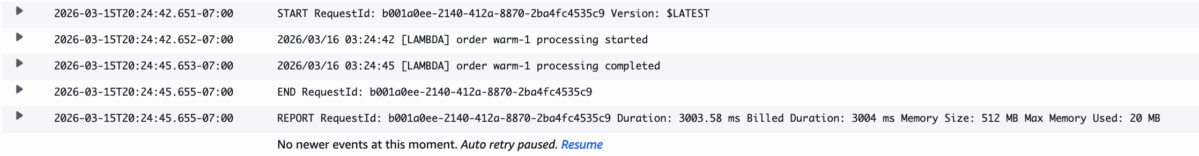

3. Cold Start Observations
From the CloudWatch logs, we observed both cold start and warm start executions of the Lambda function.

How often do cold starts occur?
Cold starts occur when the Lambda function is invoked for the first time or after a period of inactivity. In our experiment, the first request shows an Init Duration of about 71.76 ms, which indicates a cold start. Subsequent requests processed shortly afterward do not include the Init Duration field, meaning they are warm starts.
This behavior suggests that cold starts happen mainly on the first invocation or after the function has been idle for several minutes (typically around 5 minutes or more).

What is the cold start overhead?
From the logs:
- Processing duration: about 3002 ms
- Init duration (cold start): about 71.76 ms
The cold start overhead is therefore:
71.763000≈2.4%
This means the cold start adds only about 2.4% additional latency compared to the normal processing time.

Does this matter for 3-second payment processing?
In this system, each order requires about 3 seconds of payment verification. Compared with this processing time, the ~70 ms cold start overhead is very small. Therefore, the cold start delay is unlikely to have a noticeable impact on overall system performance or user experience.
For our use case, where processing time dominates the total latency, the cold start overhead is negligible.

4. My Current Part II Cost
ECS | 2×8.50=17
Lambda per request | 0.5×3=1.5 GB-seconds
Lambda at 10,000 orders/month | 10,000×1.5=15,000 GB-seconds
Free tier comparison | 15,000<400,000, so cost 0
Max free orders | 400,000÷1.5≈267,000
For cost comparison, the current ECS-based async system runs two always-on ECS tasks, which costs about $17 per month based on the assignment assumption of $8.50 per task. In contrast, the Lambda version only charges per request and execution time. With 512MB memory and 3 seconds of processing time, each order uses 1.5 GB-seconds. For 10,000 orders per month, the total usage is 15,000 GB-seconds, which is well below the AWS free tier of 400,000 GB-seconds and 1 million requests. Therefore, the monthly Lambda cost would be $0. For this workload, Lambda is much cheaper than ECS. It also remains free until around 267K orders per month, and only around 1.7 million requests per month would make the Lambda cost approach the $17/month ECS cost.
5. Should your startup switch to Lambda? Why or why not?
For our startup, switching to AWS Lambda would be a good option. Lambda removes most operational overhead because we no longer need to manage SQS queues, ECS workers, or scaling. AWS automatically handles execution and scaling for each order.
The cost advantage is also significant. Our current ECS system costs about $17 per month because the services run continuously. In contrast, Lambda charges only when requests are processed. For about 10,000 orders per month, the system stays within the AWS free tier, so the monthly cost is $0.
The cold start overhead is small. From our logs, the cold start adds about 71 ms, which is only about 2.4% of the 3-second payment processing time, so it has little impact on performance.
However, Lambda has weaker reliability guarantees because it does not provide the same queuing and retry control as SQS. Despite this limitation, for a small startup with moderate traffic, Lambda provides a simpler and more cost-efficient solution, so switching to Lambda would be reasonable.

